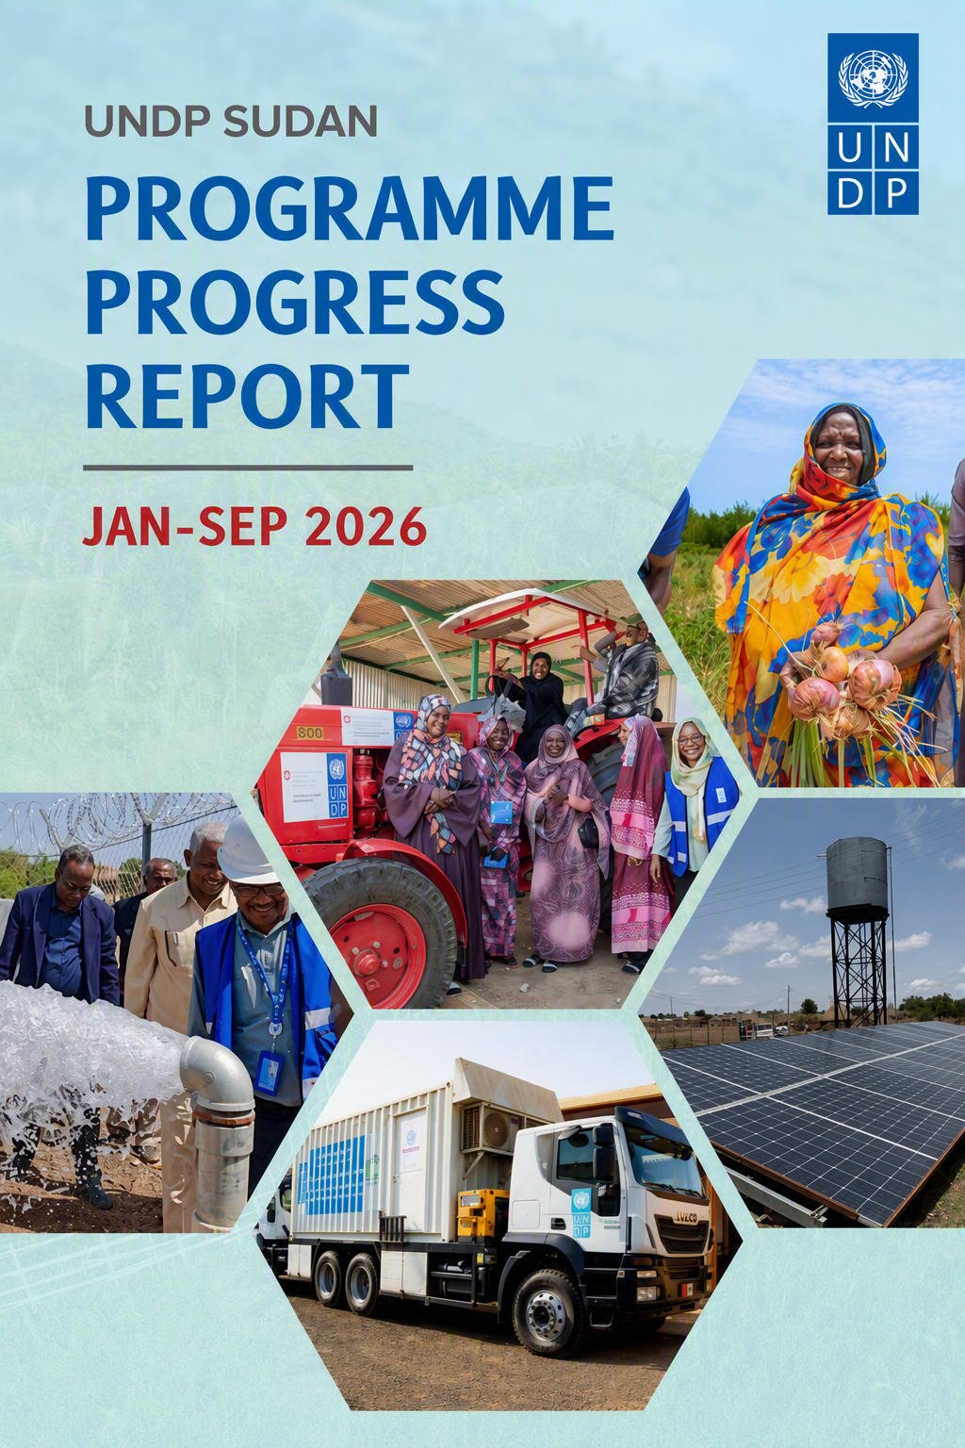
Sudan CO Programme Progress Report January-September 2026

Executive Summary and Key Progress Snapshot
Despite a highly challenging operating environment characterized by protracted conflict, large-scale displacement, economic instability, and rising humanitarian needs, UNDP Sudan continued to deliver integrated solutions that connect humanitarian response, recovery, resilience-building, and sustainable development. Through adaptive programming, strategic partnerships, and area-based approaches, UNDP expanded access to essential services, strengthened livelihoods, enhanced climate resilience, and promoted social cohesion across Sudan.

Between January and September 2026, UNDP reached more than 7 million people, including 48% women, through interventions implemented under its Health, Recovery and Resilience, Peacebuilding and Inclusive Governance, and Environment, Energy and Climate Change pillars.

These efforts improved access to healthcare and essential services, strengthened livelihood opportunities and food security, enhanced resilience to climate and socioeconomic shocks, and supported locally led recovery and peacebuilding initiatives, contributing to the achievement of Country Programme and Sustainable Development Goal commitments.

Key Results Achieved and Strategic Contribution to Country Programme Outcomes
Table 1: Progress in Beneficiary Reach Against Approved 2026 Integrated Work Plan (IWP) Targets (January-September 2026)
Pillar | Beneficiaries Target | Reached direct+ indirect | % Achieved | % of Women
🩺 Health | 8,511,342 | 5,509,874 | 64% | 61%
💼 Livelihoods and Economic Recovery | 1,610,404 | 1,561,005 | 97% | 36%
🕊 Peacebuilding and Social Cohesion | 19,079 | 15,943 | 84% | 44%
🌱 Climate Resilience and Environment | 163,351 | 116,001 | 71% | 49%
Total | 10,304,176 | 7,202,823 | 79% | 48%

Knowledge Management
Through the production of high-quality analytical products and the promotion of policy dialogue, UNDP reinforced its role as a strategic advisor to national stakeholders, contributing to evidence-based policymaking and informed decisions on Sudan's recovery and development agenda.

Risk Management and Data Validation
UNDP Sudan continued to strengthen risk-informed programming and data quality throughout the reporting period. Enhanced beneficiary verification, data validation, and quality assurance processes ensured the reliability of reported results, strengthened accountability, and supported evidence-based planning and performance reporting across all programme pillars.

Priority Actions for October-December 2026
During the final quarter of 2026, the M&E and Data Team will prioritize strengthening data management systems, enhancing data quality assurance and beneficiary verification processes, completing outstanding validation exercises, and expanding the use of standardized digital tools. These efforts will contribute to improved results reporting, stronger performance monitoring, and more effective evidence-based decision-making.

Map 1: UNDP Interventions Coverage (Jan–Sep 2026)

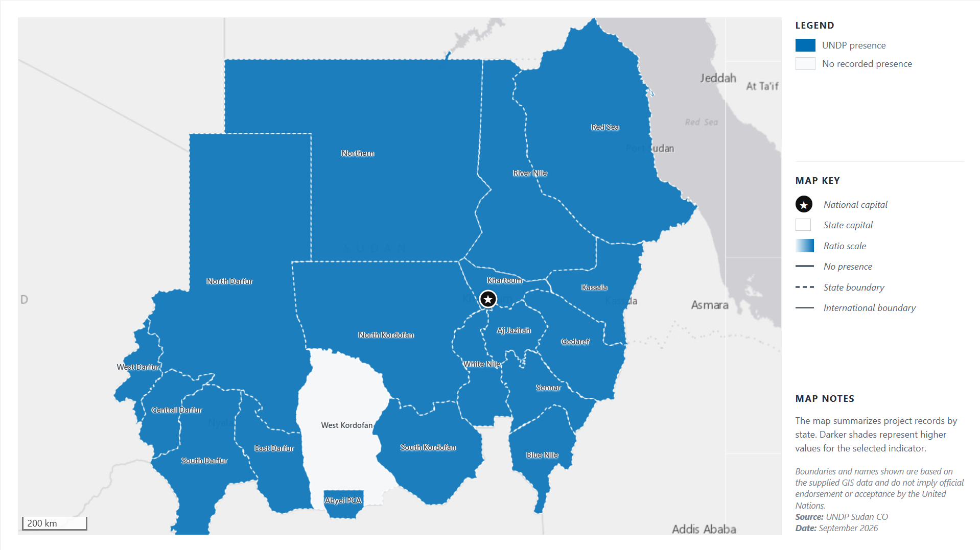

Context Overview (Jan-Sep 2026)
Throughout the first nine months of 2026, Sudan continued to face a complex humanitarian, recovery, and development landscape characterized by the protracted effects of conflict, widespread displacement, economic fragility, and growing protection concerns. Humanitarian needs remained among the highest globally, with over 8.8 million internally displaced persons (IDPs) and millions more requiring urgent assistance, placing immense pressure on already overstretched basic services, infrastructure, and local coping mechanisms. Food insecurity remained a critical concern, with famine risks persisting in several conflict-affected areas, particularly across Darfur and Kordofan regions, while constrained humanitarian access and recurrent shocks continued to limit the delivery of life-saving assistance.

Despite the challenging operating environment, gradual improvements in security conditions in some parts of the country facilitated the resumption of economic and social activities, supporting early recovery efforts and localized return movements. Economic activity showed signs of modest recovery during 2026, driven by the reopening of markets, restoration of selected productive activities, and increasing investments in recovery and reconstruction initiatives. However, the benefits of this recovery remained uneven and fragile. Persistent macroeconomic instability, high inflation, limited access to finance, disrupted value chains, and constrained employment opportunities continued to undermine household resilience and livelihoods, particularly among displaced populations, women, youth, and vulnerable communities.

Returns to relatively stable areas increased during the reporting period, reflecting the aspirations of affected populations to rebuild their lives and livelihoods. Nevertheless, returnees continued to face considerable challenges, including damaged or destroyed infrastructure, inadequate housing, limited access to healthcare, education, water and sanitation services, and insufficient livelihood and income-generating opportunities. The widespread destruction of productive assets and community infrastructure further constrained sustainable reintegration and recovery prospects.

External economic pressures also continued to affect Sudan's recovery trajectory. Global and regional market disruptions, rising transportation and insurance costs, and continued volatility in international trade routes contributed to elevated prices of imported goods, including fuel, food, and essential commodities. Periodic shortages of fuel and other critical supplies affected service delivery, agricultural production, and local economic activities across several states. Consequently, inflationary pressures remained high throughout 2026, eroding purchasing power, increasing the cost of living, and exacerbating vulnerabilities among already affected populations.

Against this backdrop, humanitarian, development, and peacebuilding actors continued to prioritize integrated and area-based approaches aimed at addressing immediate needs while strengthening community resilience, supporting recovery, restoring basic services, promoting social cohesion, and creating pathways towards longer-term stability and sustainable development. These efforts remained critical to bridging humanitarian response and recovery while supporting vulnerable populations and host communities in navigating an increasingly complex and evolving context.

Key Results Dashboard (January-September 2026) by Programme Pillar/Outcome Area:
Despite operating in a highly challenging context characterized by continued conflict, displacement, economic instability, and increasing humanitarian needs, UNDP successfully reached more than 7 million people, including 48% women, across Sudan through integrated, area-based, and community-centred interventions.

The results achieved during the reporting period reflect significant progress in strengthening community resilience, enhancing the responsiveness of health systems, expanding equitable access to essential services, and supporting vulnerable populations to recover from the impacts of protracted crises. Through its integrated programming approach, UNDP continued to advance recovery, resilience, and sustainable development outcomes, contributing to improved well-being and strengthened prospects for long-term stability and inclusive growth.

Health Systems Strengthening and Resilient Service Delivery

Pillar # 1: Health - Access to Functional, Inclusive and Equitable Essential Services.
Related Strategic Plan outcome 1: By 2029, prosperity is increased for all, strengthening people's agency, capabilities and dignity to thrive.

Progress Under UN-ICF/CPD Outcome 1: “By 2028, more people across Sudan—particularly those in vulnerable situations—have improved access to functional, inclusive, equitable, integrated, quality, safe, and sustainable essential services that enhance their well-being and resilience”.

UNDP reached over 5.5 million people (61% women) with access to essential health services, improving the availability and continuity of healthcare, life-saving medicines, diagnostics, disease prevention, and treatment services, strengthening health system resilience through investments in workforce capacity, and renewable energy solutions. Integrated, climate-resilient interventions further improved access to water, food security, and basic services, contributing to recovery and resilience in vulnerable and conflict-affected communities.
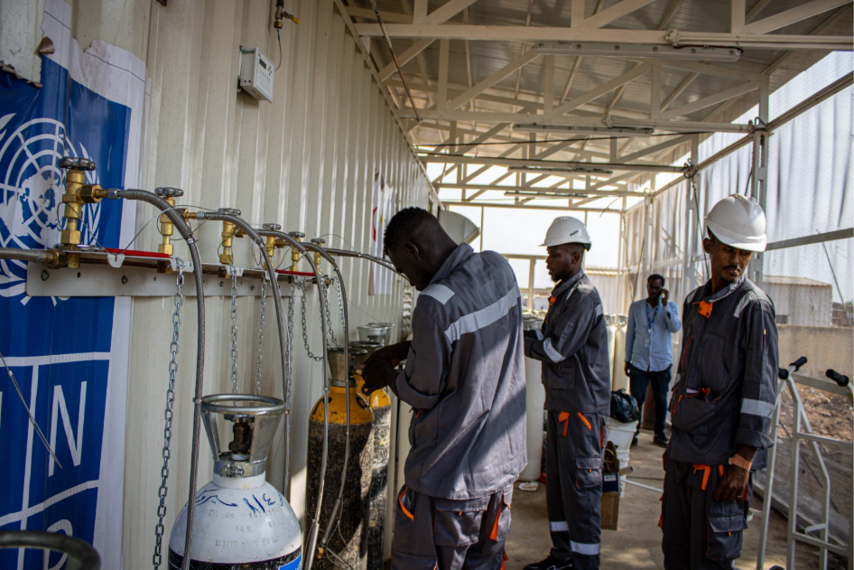
Figure 1. UNDP Sudan Health Pillar – Beneficiaries Reached Through Health Interventions

Progress under CPD Output 1.1 “National systems and structures are improved to enhance access, availability, affordability, and equity in healthcare”.
UNDP continued to strengthen the resilience and recovery of Sudan’s health system by supporting the delivery of essential healthcare services, enhancing institutional capacities, and investing in health infrastructure. Through strategic partnerships, UNDP improved access to primary healthcare, essential medicines, HIV and tuberculosis services, and diagnostic care, while advancing the installation of an MRI unit in Kassala State expected to benefit approximately 1.5 million people. Integrated interventions across health, resilience, environment, and climate programmes further improved access to water, food security, and basic services, contributing to reduced vulnerabilities and strengthened community resilience in crisis-affected areas.

Output 1.2 “Vulnerable and displaced communities have improved access to safe, adequate, and sustainable water sources”
UNDP complemented health-sector interventions through integrated initiatives aimed at improving access to safe water and strengthening climate-resilient community systems. Interventions focused on rehabilitating and solarizing water infrastructure, enhancing the reliability and sustainability of water supply systems, and promoting community-based management mechanisms to improve service delivery and local ownership.

Investments in renewable energy solutions and community infrastructure further improved access to services, enhanced safety and mobility, and strengthened local resilience. Collectively, these interventions contributed to improved living conditions and expanded access to essential services for vulnerable and displaced populations.

Progress Towards 2026 IWP Targets (please refer to annex for detailed results 1):
Health and Essential Services
Between January and September 2026, UNDP reached more than 5.5 million people (61% women and girls) through health and essential service interventions implemented across nearly 120 locations in multiple states of Sudan. These achievements were delivered through strategic investments in health infrastructure, service delivery, and system strengthening, contributing significantly to annual Integrated Work Plan (IWP) targets.
Key results achieved include:
- 4,677,963 people gained access to improved healthcare services through investments in critical health infrastructure and systems, including oxygen supply systems and PSA oxygen plants, healthcare waste management incinerators, solarization of health facilities, and other essential health service delivery interventions.
- 598,586 people benefited from HIV, Tuberculosis (TB), and Primary Health Care (PHC) services, supporting continued access to life-saving and routine healthcare services.
- 45,000 people living with diabetes received life-saving insulin and related treatment support, helping to ensure continuity of care for individuals with chronic health conditions.
- 646 health personnel were trained during 2026 to strengthen the capacity of healthcare institutions and improve service quality. Training focused on:
  - Healthcare waste management.
  - Incinerator operation and maintenance.
  - Oxygen PSA plant operation and maintenance.
  - Prevention, Diagnosis, care, and treatment of TB and HIV.
  - Awareness raising, Human rights, and stigma reduction.
Collectively, these interventions strengthened access to essential healthcare services, enhanced the resilience of health systems, improved service quality, and built the capacity of health workers to respond effectively to the growing health needs of vulnerable populations across Sudan.

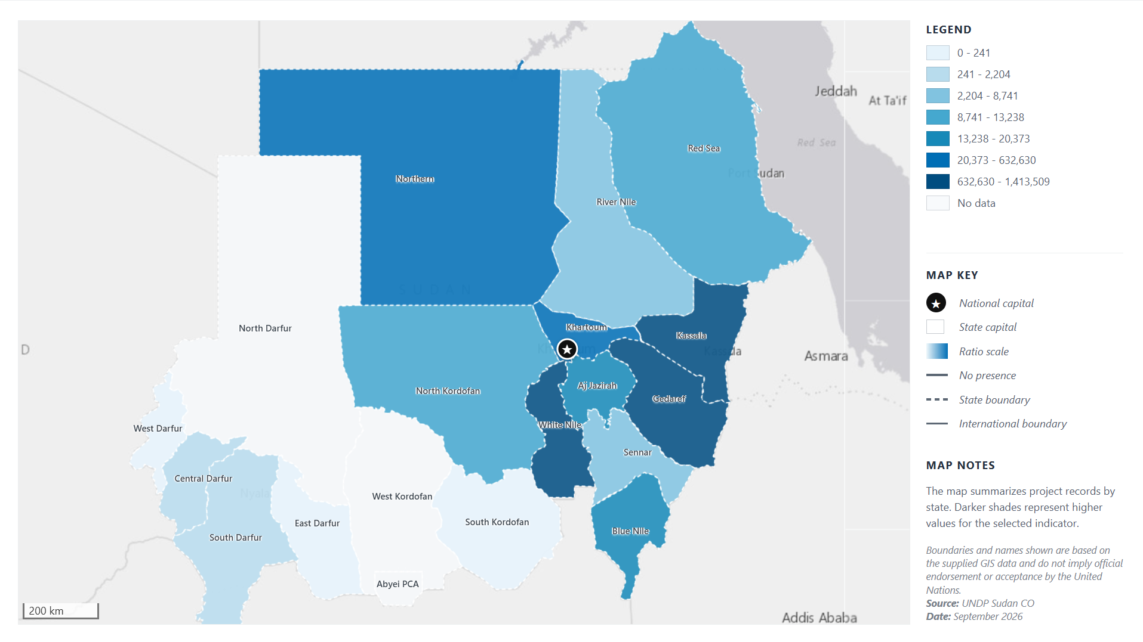
Figure 1. Map of Health Pillar Interventions and Geographic Coverage Across Sudan, Showing the Number of Targeted People Reached to Date Through Varying Scale Ratios (2026)

Pillar # 2: Resilience & Recovery (R&R) Pillar: Economic empowerment and private sector recovery

Related Strategic Plan Outcome 3: By 2029, institutions and people are better prepared to prevent, respond to and recover from crises while sustaining long term development

Progress made under UN-ICF/CPD Outcome #2: By 2028, more people across Sudan — particularly groups in vulnerable situations — benefit from inclusive economic opportunities, sustainable jobs and resilient livelihoods, and improved food security.

Under Programme Priority 2, UNDP continued to support inclusive livelihood recovery and economic resilience interventions aimed at strengthening food security, restoring incomes, and expanding economic opportunities for targeted vulnerable populations. Through a combination of agricultural production support, climate-smart farming practices, sustainable water solutions, skills development, cash-for-work initiatives, income generation, economic inclusion, and employment opportunities/ resilience among vulnerable communities across targeted states, UNDP helped over 1,6 million (36% women) benefited from integrated livelihood interventions between January and September 2026, contributing to improved food security, sustainable income streams, and essential services powered through renewable energy.

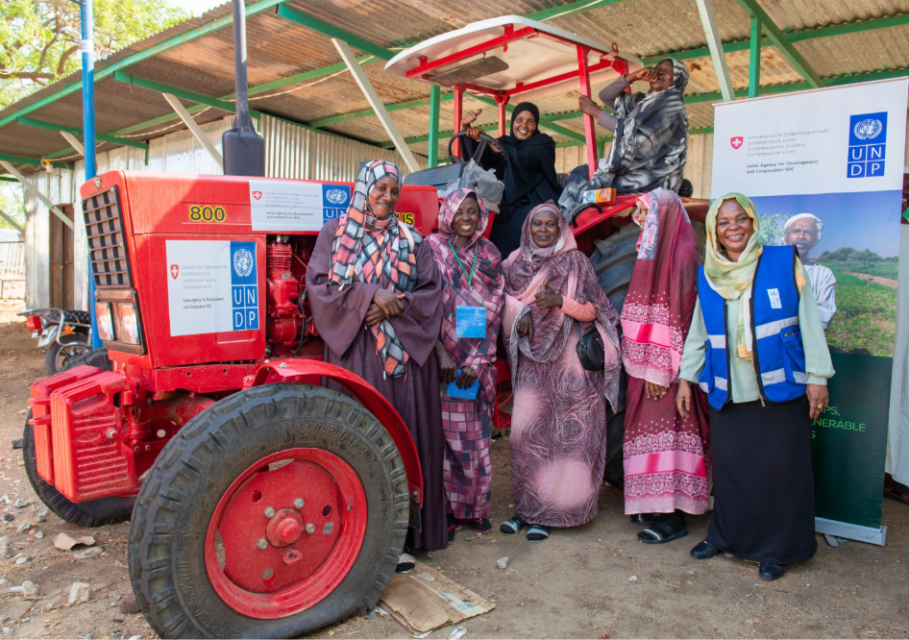
Figure 2. UNDP Sudan – Beneficiaries Reached Through Resilience & Recovery Pillar Interventions

Progress under outputs:
Output 2.1 | The Federal Government's economic modelling, planning, financing and implementation capacity for recovery and development coordination strengthened.
Output 2.2 | Sudan's MSME sector (including women and youth-led MSMEs) is provided with an enabling business environment that provides access to innovative financing solutions.
Output 2.3 | Vulnerable and displaced communities, with a focus on women and youth, access productive infrastructure and immediate and longer-term economic opportunities.

Progress Towards 2026 IWP Targets (please refer to annex for detailed results 1):
1,561,005 individuals (36% women) benefited from integrated livelihood interventions between January and September 2026, contributing to improved food security, sustainable income streams, and essential services powered through renewable energy. Out of which:
- 111,489 individuals received agricultural inputs, seeds, tools and extension services including agricultural associations that utilized heavy duty tractors to increase their production, benefiting 510,194 community members indirectly.
- 23,200 people gained access to clean, safe drinking water through established and rehabilitated solarized water yards, benefiting 39,200 community members indirectly. An additional 260,070 farmers gained access to improved water through solarized irrigation schemes and rehabilitated water canals reviving agricultural activity creating multiplier benefits for an extended 11,680 small-holder farmers.
- 18,440 people received capacity building spanning vocational training, cost recovery systems and community management through Community Management Committees (CMCs) and Water User Associations (WUAs) enabling self-sustained access to critical services reaching 177,450 extended households beyond project lifecycles.
- 21,995 people received immediate financial resources (cash for work) through temporary employment opportunities provided by cash-for-work schemes, enabling them to support an additional 64,370 community members indirectly through multiplier effects of cleaning campaigns, communal spending and cost-sharing for community infrastructure.
- 17,229 people received job opportunities through various micro-grants to establish small-scale businesses and create long-term sources of income through self-employment. 39% were women empowered through VSLAs and income-generating groups to launch small-businesses including women who received access to financial services. Altogether, these support an additional 123,788 community members through improved household income covering education, health services and dignified living conditions.
- Other interventions geared towards improving community resilience have reached 74,700 people through social cohesion forums, shared infrastructure rehabilitation including health centers, distribution of solar kits and installation of solar streetlights, extending reach to 107,200 community members significantly reducing associated GBV risks.

Overall, these achievements have contributed to recovery of local economies, strengthening the resilience of host communities and displaced populations, enhancing social cohesion, and expanding access to essential services. The results demonstrate UNDP’s continued contribution to fostering inclusive economic growth, supporting private-sector recovery, and advancing sustainable recovery and resilience outcomes across Sudan.

Figure 2. Map of Recovery & Resilience Pillar Interventions and Geographic Coverage Across Sudan, Showing the Number of Targeted People Reached to Date Through Varying Scale Ratios (2026)

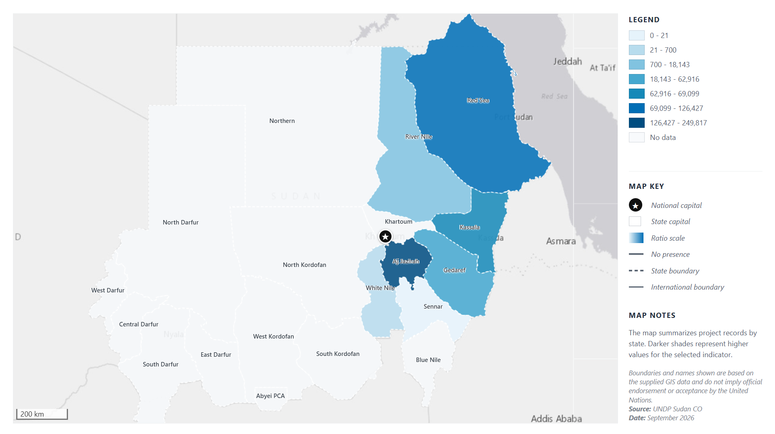

Pillar # 3. Peacebuilding and Inclusive Governance Pillar:

Related strategic Plan: Outcome 2: By 2029, governance systems are more effective, inclusive, and accountable, enabling people, societies and economies to thrive

UN-ICF/CPD Outcome #3: By 2028, more people across Sudan — particularly groups in vulnerable situations — live in a safer and more peaceful society with strengthened human rights protections, inclusive institutions, and equitable access to justice.

Between January and September 2026, UNDP strengthened peacebuilding, social cohesion, and community protection efforts by supporting locally led conflict prevention, mediation, and dialogue mechanisms. Through community-based initiatives recached 15,943 people (873 direct and 14,534 indirect/(44%women), were reached with interventions that promoted peaceful coexistence, strengthened community resilience, enhanced protection mechanisms, and fostered the meaningful participation of women, youth, displaced populations, and other vulnerable groups. These efforts aimed to reducing conflict risks, strengthening social cohesion, and advancing community-led solutions for sustainable peace and inclusive governance.

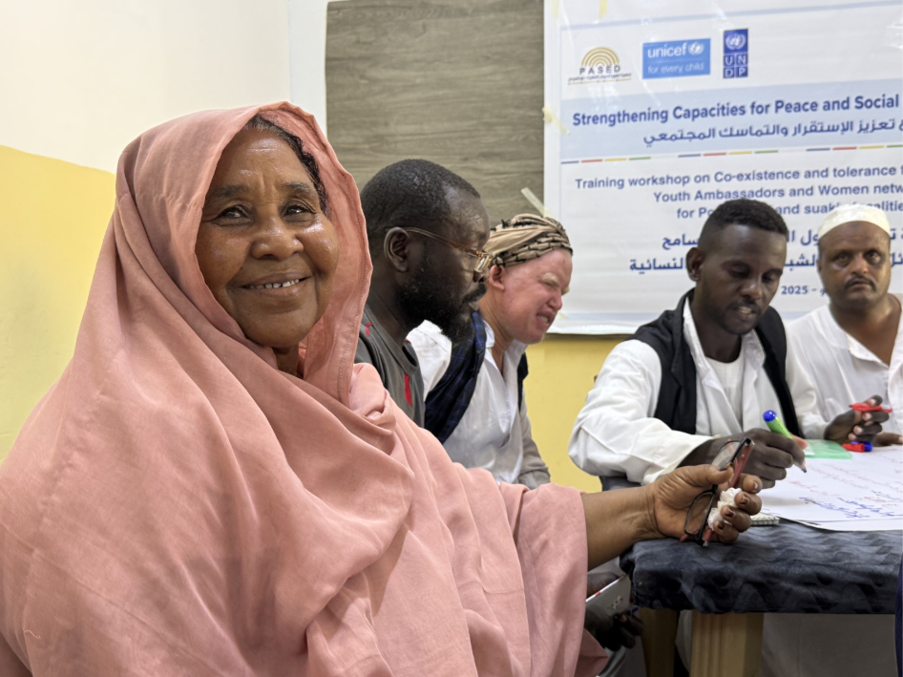
Figure 3. UNDP Sudan – Beneficiaries Reached Through Peacebuilding & Governance Pillar

Progress Towards 2026 IWP Targets (please refer to annex 1):

CPD Output 3.1 | Local actors, including youth and women, have enhanced mediation, dialogue, negotiation, and context analysis capacities and are participating in transitional and peacebuilding processes.
CPD Output 3.2 | Formal and traditional justice systems strengthened to address gender-based violence and other justice needs.

In total 15,943 people (873 direct and 14,534 indirect/(44%women), were reached through interventions focused on community protection, mediation, peacebuilding, and social cohesion between January and September 2026.
- UNDP supports a nationwide network of Academic Peace Centres, providing an impartial platform for conflict analysis, dialogue, locally led peacebuilding initiatives, and the preservation of professional relationships across conflict lines. As part of this effort, UNDP brought together 60 participants representing 22 Academic Peace Centres from all states across the country, strengthening collaboration, knowledge exchange, and coordinated peacebuilding efforts at the national level.
- Support was provided through the reactivation and strengthening of community-based protection and peacebuilding mechanisms, enabling local actors to play a greater role in conflict prevention and resolution.
- Community members, including women, youth, displaced populations, and other vulnerable groups, participated in initiatives that promoted inclusive dialogue, peaceful coexistence, and community engagement.

These achievements aimed to strengthen Sudan’s local peace architecture, promote community participation in peace processes, and advance UNDP’s objective of creating a peaceful, safe, and inclusive environment that supports social cohesion, human rights, and sustainable peacebuilding.

Figure 3. Map of Peacebuilding & Inclusive Governance Pillar Interventions and Geographic Coverage Across Sudan, Showing the Number of Targeted People Reached to Date Through Varying Scale Ratios (2026)
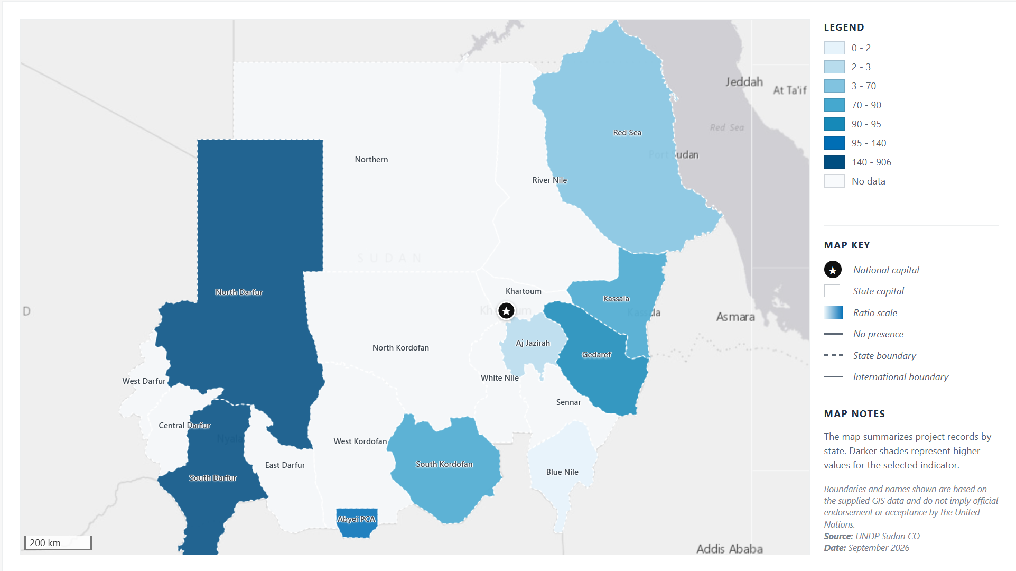

Pillar # 4. Environment, Energy & Climate Change: Water, Clean Energy and Climate Resilience
Related Strategic Plan Outcome 4: By 2029, international environmental agreements are mainstreamed into national development frameworks to drive sustainable development

UN-ICF/CPD Outcome #4: By 2028, more people across Sudan — particularly groups in vulnerable situations — benefit from clean energy sources and sustainable management of natural resources, and are more resilient to climate change impacts, environmental stresses, and disaster risks.

Under Programme Priority 4, UNDP support aims to strengthen climate resilience, clean energy access, and environmental sustainability by supporting integrated approaches that link climate adaptation, disaster risk reduction, sustainable livelihoods, and ecosystem restoration.

Building on Sudan’s climate commitments and national priorities, interventions focused on expanding access to renewable energy solutions, particularly solar-powered systems for water services, livelihoods, and community infrastructure; promoting climate-smart agriculture and nature-based solutions; enhancing environmental governance and climate risk management capacities; and supporting inclusive, gender-responsive approaches to climate action. Through partnerships with government institutions, UN agencies, civil society, and international climate financing mechanisms, UNDP contributed to improving communities’ resilience to climate shocks, environmental degradation, and disaster risks while advancing sustainable development, green growth, and equitable access to clean energy for vulnerable populations across Sudan.

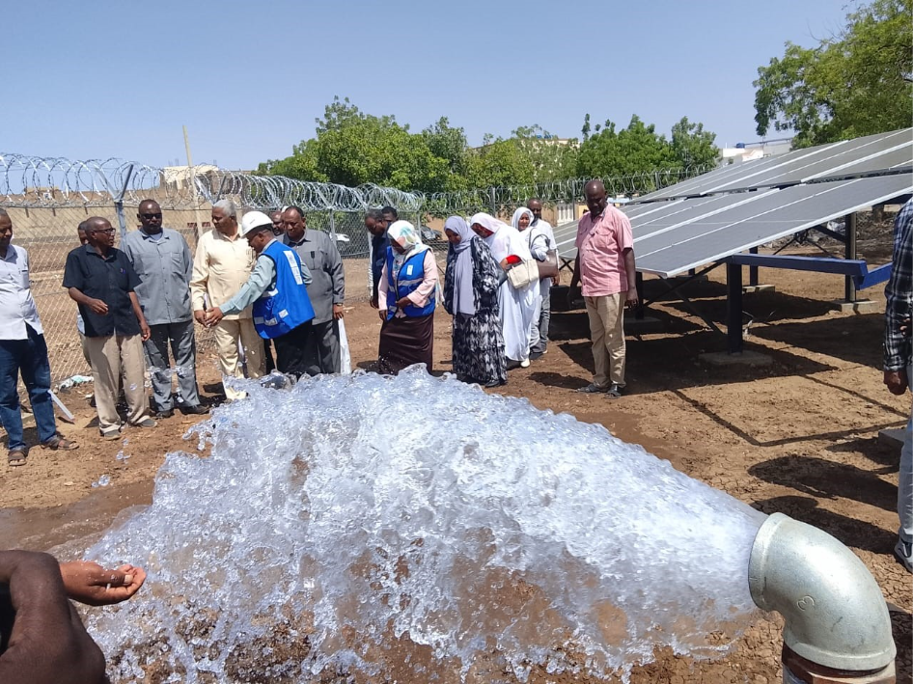
Figure 4. UNDP Sudan – Beneficiaries Reached Through Environment, Energy & Climate Change
Progress against outputs:
CPD Output 4.1 | Renewable energy solutions, for productive and domestic use, provided to communities living in off-grid areas through public and private service delivery agents.
CPD Output 4.2 | Capacity of national and sub-national entities strengthened to enhance resilience of climate-vulnerable population.
CPD Output 4.3 | Improved national, local, and inclusive community-based governance mechanisms for ecosystem restoration and nature-based solutions.

Progress Towards 2026 IWP Targets (please refer to annex 1):
Water, Clean Energy and Climate Resilience
A total of 116,001 people (49% women) benefited from interventions in water, clean energy, and climate resilience. This included 47,380 people gaining access to electricity through the installation of new solar energy infrastructure, including solar streetlights and solar 3-in-1 kits. In addition, communities benefited from improved access to safe water through the establishment and rehabilitation of solar-powered water systems and water yards. Furthermore, 12,980 farmers received solar-powered irrigation systems, contributing to enhanced agricultural productivity and supporting increased food production for an estimated 20,980 people.

Figure 4. Map of Environment, Energy & Climate Change Pillar Interventions and Geographic Coverage Across Sudan, Showing the Number of Targeted People Reached to Date Through Varying Scale Ratios (2026)
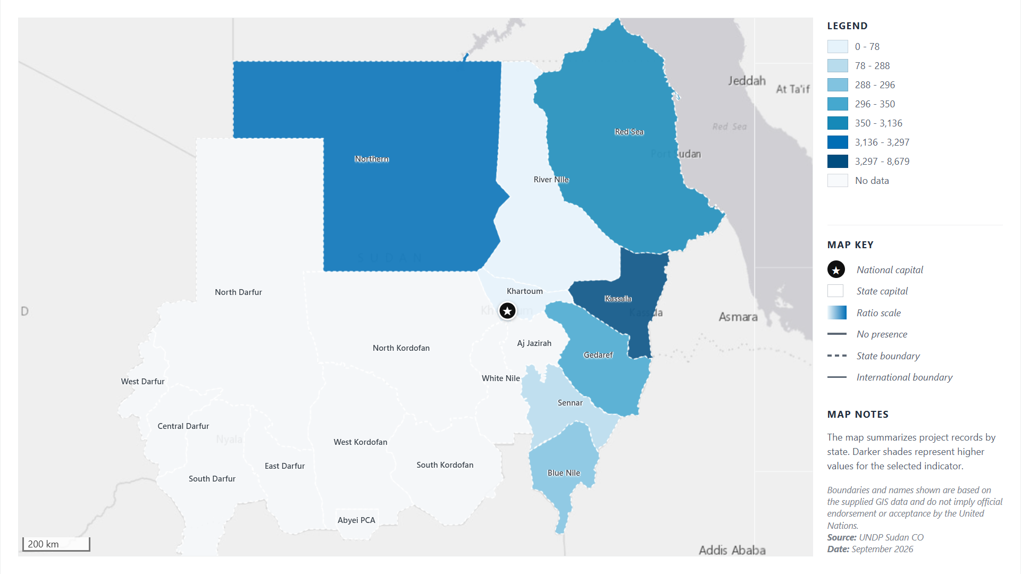

Beneficiaries’ data collection and validation exercise
For beneficiary data collection, UNDP applied a rigorous data validation approach based on triangulation and cross-checking of information from multiple sources to enhance the accuracy and credibility of reported results. Data were systematically reviewed and compared across different datasets and programme interventions to identify inconsistencies and ensure reliability. This process was complemented by regular monitoring and review meetings, quality assurance checks, and continuous data management procedures, which strengthened data quality, improved consistency, and ensured that evidence generated across the four programme pillars was accurate, complete, and fit for reporting and decision-making purposes.

Flagship Publications - Knowledge and Policy Engagement
Through the production of high-quality analytical products and the promotion of policy dialogue, UNDP reinforced its role as a strategic advisor to national stakeholders, contributing to evidence-based policymaking and informed decisions on Sudan's recovery and development agenda.
Product | Strategic Contribution
Solar Energy Value Chain Study | Provided evidence and policy recommendations to advance renewable energy recovery, strengthen energy access, and support economic resilience in conflict-affected areas.
Private Sector Engagement Strategy | Identified practical interventions to support economic recovery, private sector revitalization, and inclusive growth, with a focus on women, youth, and displaced populations.
Beyond the Conflict: Charting a Path to Sustainable Growth and Development in Sudan | Presented long-term recovery scenarios, quantified the socioeconomic costs of conflict, and outlined policy options for sustainable recovery and development.

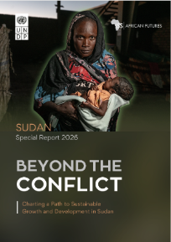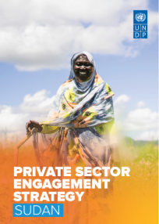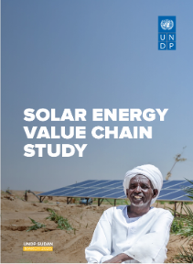
UNDP made significant progress in finalizing several under preparation knowledge products and is coordinating a public private sector dialogue in Sudan to strengthen partnership and mobilize resources for private sector recovery in Sudan.

Key Challenges/Risks During the Reporting period:
UNDP Sudan strengthened risk management in beneficiary data collection by implementing robust data quality assurance, verification, and risk monitoring processes to ensure the accuracy, reliability, and integrity of beneficiary information. Through regular data validation, triangulation of data from multiple sources, spot checks, and cross-verification with implementing partners and supporting documentation, potential risks such as duplicate records, data inaccuracies, exclusion errors, and reporting inconsistencies were identified and addressed in a timely manner. Continuous monitoring of data collection processes, coupled with periodic data quality assessments and performance reviews, enabled the Country Office to detect emerging operational and programmatic risks, adapt data collection strategies to challenging and conflict-affected contexts, and ensure that beneficiary data remained credible and fit for evidence-based decision-making, reporting, and resource allocation.

Key Challenge | Impact on Programme Implementation | Mitigation Measures
Continued Conflict, Insecurity and Population Displacement | Ongoing conflict and a volatile security environment constrained access to vulnerable populations, disrupted service delivery, and restricted the movement of personnel, partners, and supplies. Continued displacement and population movements increased pressure on already overstretched services and complicated targeting, monitoring, and beneficiary tracking. | • Adopted adaptive and flexible programming approaches to respond to changing security conditions.  • local partnership: Leveraged local implementing partners and community-based organizations to maintain service delivery in accessible areas.  • Strengthened remote management, monitoring, and digital data collection mechanisms where physical access was limited.  • Prioritized area-based interventions and coordinated closely with humanitarian actors to improve reach and targeting of displaced populations.
Economic Instability and Rising Operational Costs | High inflation, currency depreciation, fuel shortages, and rising transportation and commodity costs increased implementation expenses and affected the timely delivery of programme activities. The deteriorating economic situation also reduced community purchasing power and challenged the sustainability of livelihood recovery efforts. | • Enhanced financial planning and regular budget reviews to manage inflationary pressures.  • Increased reliance on local procurement and supply chains where feasible.  • Prioritized cost-effective implementation modalities and optimized resource allocation.  • Expanded livelihoods and income-generating activities to strengthen community resilience and economic recovery.
Limited Institutional and Service Delivery Capacities | Conflict-related damage to infrastructure and weakened institutional capacities reduced the ability of national and local actors to deliver essential services. Shortages in technical expertise, staffing, operational resources, and functional systems continued to affect programme implementation and sustainability. | • Continued investments in institutional capacity development and systems strengthening.  • Provided technical assistance, training, and operational support to government counterparts and service providers.  • Supported rehabilitation of critical infrastructure and service delivery systems where feasible.  • Strengthened partnerships with local organizations and communities to enhance sustainability and local ownership of interventions.

Lessons Learned and Way Forward/Recommendations
During the first three quarters of 2026, UNDP Sudan achieved strong progress across its programme portfolio, reaching approximately 80% of the planned beneficiary targets. Performance was driven by effective partnerships, strong community engagement, expanded programme coverage, and sustained demand for essential services in accessible areas, enabling the Country Office to deliver significant results for vulnerable populations.
Despite these achievements, progress toward some targets was affected by continued access constraints, insecurity, population displacement, and operational challenges in conflict-affected locations. These factors limited the implementation of certain planned activities and affected beneficiary outreach, data collection, and verification processes. Nevertheless, adaptive programming approaches and close engagement with partners helped mitigate disruptions and sustain programme delivery in a highly dynamic operating environment.

These experiences highlighted the importance of maintaining flexible and adaptive implementation approaches, strengthening partnerships with local communities and local organizations, and utilizing risk-informed planning to adjust programming in response to evolving contexts. Moving forward, UNDP Sudan will continue to enhance beneficiary targeting, strengthen monitoring and data collection systems, and expand decentralized implementation mechanisms to improve coverage, ensure accurate beneficiary tracking, and increase the likelihood of achieving planned targets despite ongoing contextual challenges.

Moving forward, we will continue to strengthen beneficiary data collection systems by enhancing data quality assurance mechanisms, standardizing data collection tools and methodologies, and increasing the use of digital data collection platforms to improve efficiency and accuracy. Greater emphasis will be placed on routine data verification, triangulation, and periodic data quality assessments to ensure the reliability and integrity of beneficiary information. Capacity-building initiatives for implementing partners and field teams will be expanded to improve data management, reporting, and compliance with established standards. In addition, regular monitoring of beneficiary datasets, timely data cleaning and updating, and strengthened coordination among programme teams will support the generation of high-quality evidence for results reporting, adaptive programme management, and evidence-based decision-making. This will help ensure that beneficiary data remains accurate, comprehensive, and responsive to evolving programme and operational needs.

Key Recommendations for Future Beneficiary Data Collection and Mapping
- Accelerate Digitalization of Beneficiary Data Management: Transition from fragmented and manual data collection processes to standardized digital data collection platforms across all programme pillars. Digital tools should incorporate geotagging, real-time validation, and centralized databases to improve data quality, reduce reporting delays, and enable timely tracking of beneficiary reach and programme performance.
- Institutionalize Quarterly Beneficiary Mapping and Reporting: Establish a routine quarterly beneficiary analysis and mapping process to monitor programme coverage, trends, and progress against targets. Regular reporting will facilitate evidence-based decision-making, allow early identification of coverage gaps and underserved areas, and support adaptive programming, resource allocation, and accountability to stakeholders.
- Strengthen GIS-Supported Data Analysis and Visualization: Enhance the integration of Geographic Information Systems (GIS) into programme monitoring and reporting by developing standardized state- and locality-level beneficiary maps and dashboards. GIS-supported analysis should be used to identify geographic disparities, track changes in coverage over time, support area-based planning, and inform the prioritization of interventions in areas with the greatest needs and lowest service coverage.

MOHAMED OMER PART:

Annexes: State-Level Beneficiary Coverage Across the Four Programme Pillars
The beneficiary data analysis mapped the programme reach across all four pillars at the state and national level, highlighting the number of beneficiaries reached in each location. The maps below provide a detailed visualization of programme coverage across Sudan. In addition, the beneficiary data analysis presents an integrated view combining all four pillars, offering a comprehensive picture of the total number of beneficiaries reached nationwide. Also, the mapping exercise identified areas with both high and low beneficiary coverage, highlighting geographic disparities and service gaps. These insights provide valuable evidence for programme planning, coordination, and the targeting of future interventions.

Map 1: Raito of Beneficiary Reach Against Targets
This map illustrates progress toward beneficiary targets across states in 2026 by comparing the number of beneficiaries reached against planned targets. Color coding indicates the level of achievement in each state.
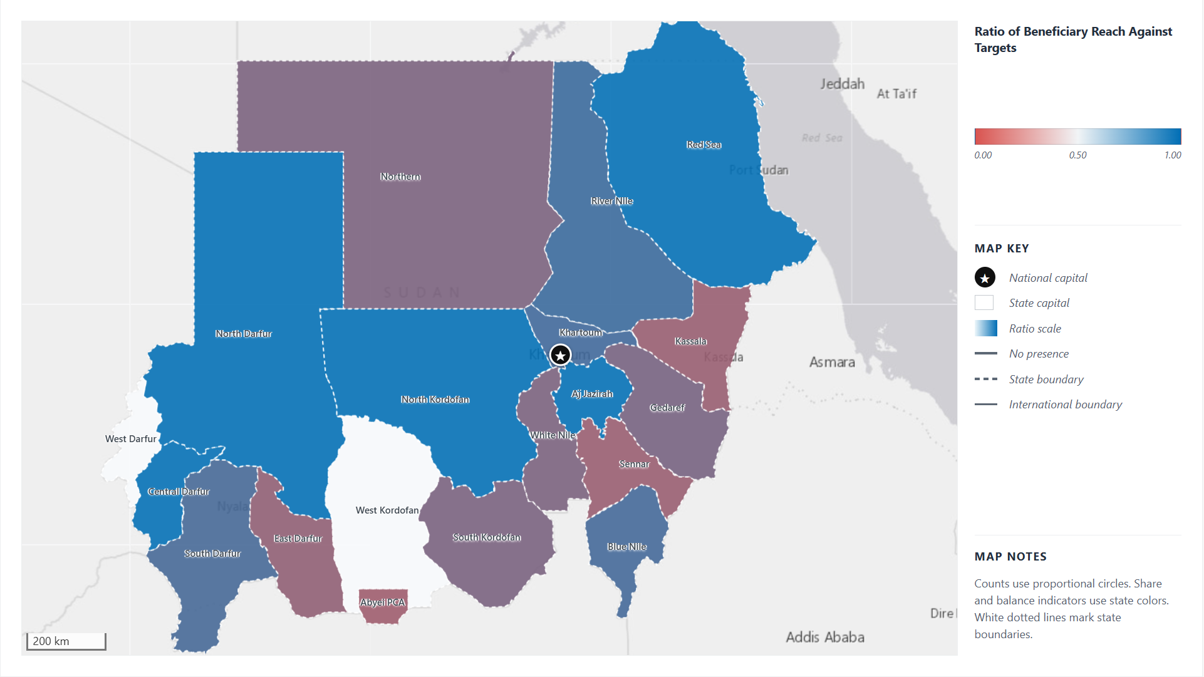

Key Insights:
- Strong Reach: North Kordofan, Central Darfur, Red Sea, Aj Jazirah, and North Darfur met or exceeded their direct beneficiary targets.
- Moderate Reach: River Nile, Khartoum, Blue Nile, and South Darfur achieved approximately 69%–75% of their planned targets.
- Lower Reach: Gedaref, South Kordofan, White Nile, Northern, East Darfur, Kassala, Sennar, and Abyei PCA remained below 50% of target achievement.
- Highest Shortfalls: Kassala and Sennar show particularly low reach ratios despite substantial planned targets. Kassala reached approximately 31% of its target.
- Mixed Darfur Performance: North Darfur and Central Darfur exceeded their targets, while South Darfur and East Darfur achieved partial progress. West Darfur has no valid target or actual values for comparison.
- Potential Scale-Up: River Nile, Khartoum, Blue Nile, and South Darfur show moderate progress with scope for further implementation gains.
- Large-Scale Priority: Gedaref and White Nile have substantial planned beneficiary volumes but reached less than half of their targets, making them important areas for operational review.
- Geographic Variation: Achievement differs considerably across states, reflecting varying implementation conditions, access constraints, programme scale, and reporting completeness. These ratios indicate target achievement, not population coverage or unmet need.
Map 3: UNDP Sudan Geographical Coverage and Pillar Presence and Overlapping
This map provides an overview of UNDP Sudan’s programme footprint across the 18 states and Abyei PCA, highlighting the presence and combination of programme pillars implemented in each location.

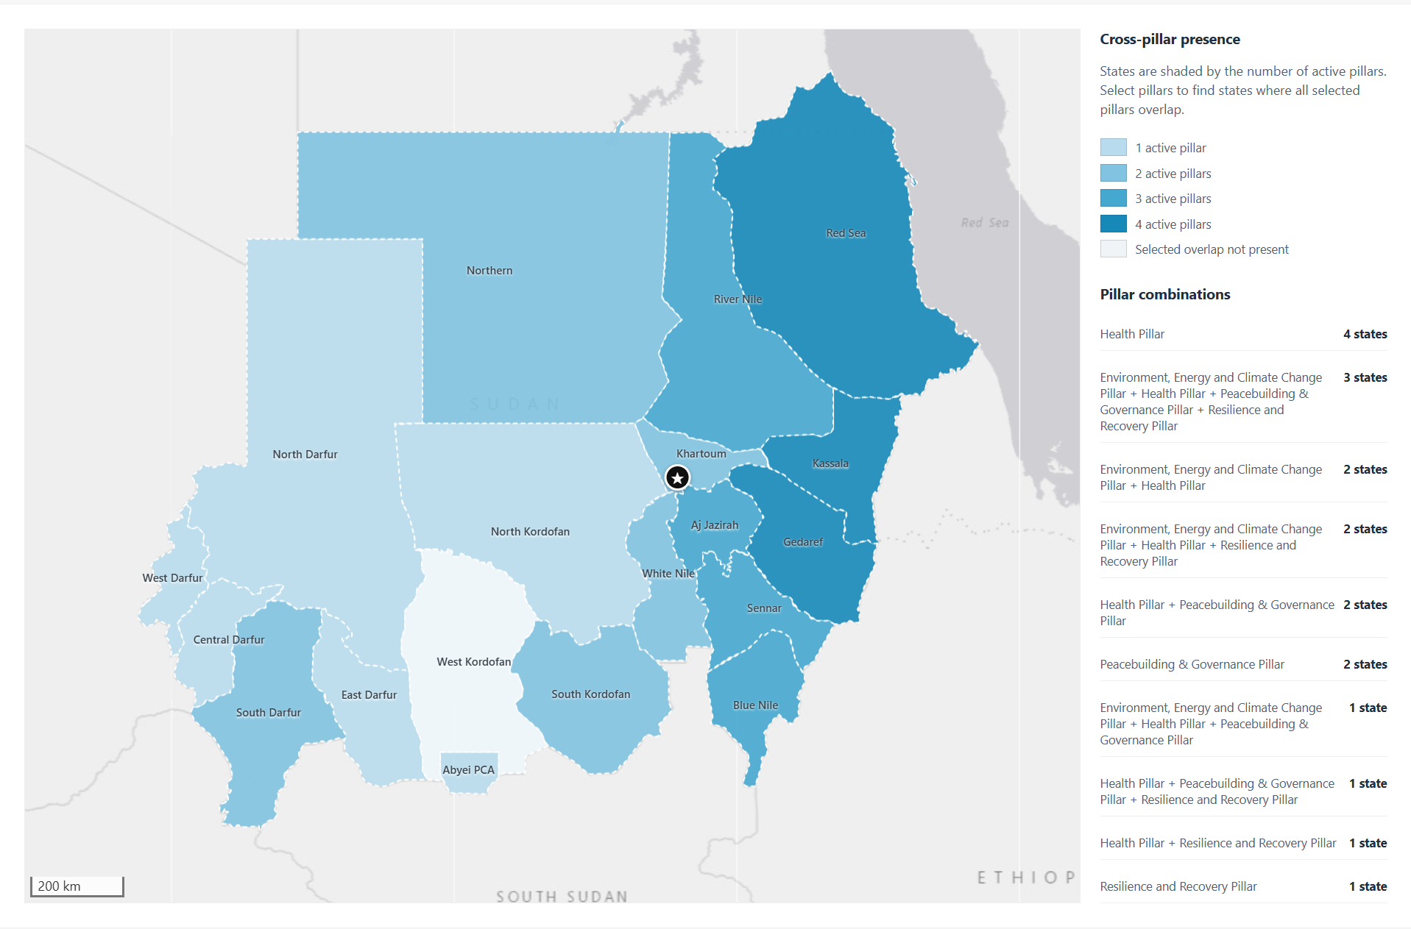

Key Insights:
- Strongest Multi-Pillar Presence: Red Sea, Kassala, and Gedaref have activities across all four pillars: Health, Environment/Energy/Climate Change, Peacebuilding & Governance, and Resilience & Recovery.
- Broad Three-Pillar Coverage: Aj Jazirah, Blue Nile, River Nile, and Sennar each show activity across three pillars, indicating relatively broad programme integration.
- Health as the Most Widespread Pillar: Health activities appear across the largest number of states and form the primary programme presence in several locations.
- Peacebuilding Concentration: Peacebuilding and Governance is present in Red Sea, Kassala, Gedaref, Aj Jazirah, Blue Nile, Sennar, South Darfur, South Kordofan, Abyei PCA, and North Darfur. In Darfur, it is strongest in North Darfur and South Darfur.
- Limited Pillar Coverage in Darfur: South Darfur has two active pillars, while North Darfur, Central Darfur, East Darfur, and West Darfur each show activity from only one pillar. This indicates more limited cross-pillar integration across much of Darfur.
- Single-Pillar States: Abyei PCA, Central Darfur, East Darfur, North Darfur, North Kordofan, and West Darfur currently show activity from only one pillar.
- Geographic Gap: West Kordofan shows no recorded programme presence in the current master data.
- Uneven Cross-Pillar Coverage: UNDP activities extend across most mapped states, but the depth of collaboration varies substantially, from single-pillar presence to four-pillar coverage.

Map 4: Beneficiaries Distribution (Female, Male and Youth)
This map presents the gender and age distribution of beneficiaries reached across Sudan’s states as of September 2026, highlighting the proportion of female, male, youth, and other beneficiary groups.
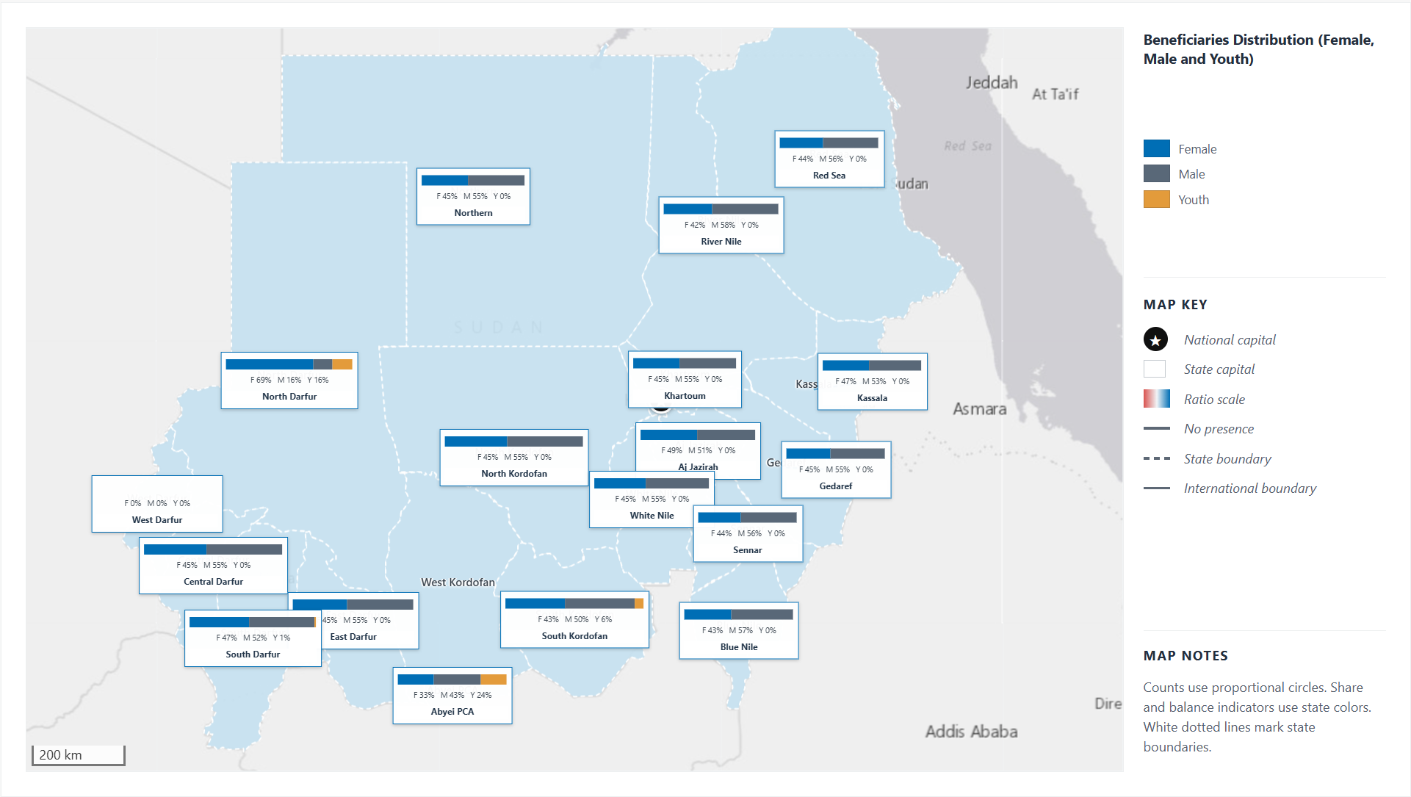
Key Insights:
- Male-Dominant Distribution: Male beneficiaries represent the largest share in most states, including Red Sea, River Nile, Blue Nile, Gedaref, Khartoum, Kassala, and White Nile.
- Female-Dominant Exception: North Darfur shows a clearly female-dominant distribution, with female beneficiaries accounting for approximately 69% of the reported total.
- More Balanced States: Aj Jazirah and Kassala show relatively balanced Female/Male distributions, although male beneficiaries remain slightly higher.
- Youth Representation: Youth beneficiaries account for a smaller share in most states. The highest reported youth representation appears in Abyei PCA and North Darfur, followed by South Kordofan and South Darfur.
- Regional Variation: Female participation is comparatively stronger in parts of Darfur, while most eastern, central, and northern states show a clearer male majority.
- Data Interpretation: Youth is reported as a separate category and may overlap with Female or Male beneficiaries. Therefore, Female, Male, and Youth percentages should be interpreted as reported demographic shares rather than mutually exclusive groups.

Map 5: Geographic Distribution of Beneficiary Reach Compared to Targets/Coverage:
The bivariate map shows the relationship between 2026 direct beneficiary targets and the number of beneficiaries reached from January to May 2026, providing a clear overview of progress against planned results across states.
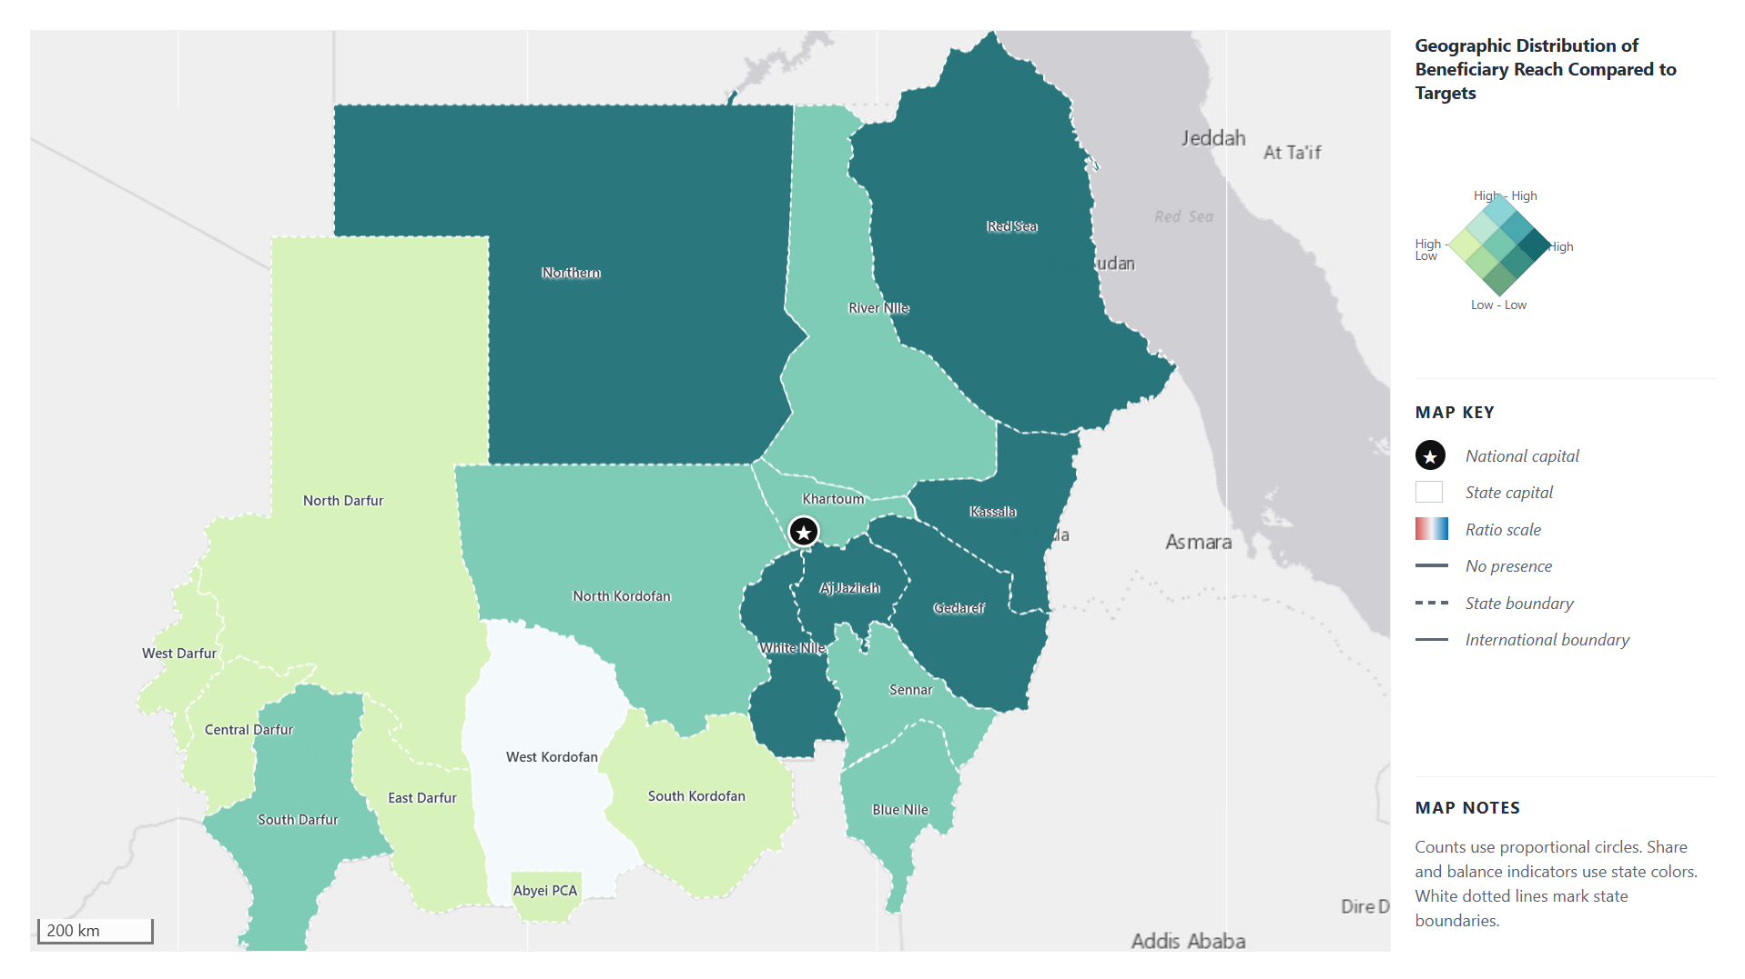
Key Insights
- Strong Progress Against Targets:
Aj Jazirah and Red Sea combine relatively substantial targets with actual reach at or above target. North Kordofan and Central Darfur also exceed their targets, although their overall target volumes are comparatively small.
- High Targets with Scope to Improve Delivery:
Kassala, White Nile, Gedaref, and Northern carry some of the largest beneficiary targets but remain below 50% achievement. These states should be prioritized for implementation review, operational strengthening, or target reassessment.
- Moderate Progress:
River Nile, Khartoum, Blue Nile, and South Darfur show intermediate achievement levels, reaching approximately 69%–75% of their targets.
- Lower Reach and Potential Constraints:
Sennar, Abyei PCA, East Darfur, and South Kordofan show lower target achievement. Their results may reflect implementation, access, reporting, or operational constraints.
- Limited or Missing Coverage:
West Darfur has no valid target or actual value for comparison, while West Kordofan shows no recorded programme presence in the current dataset. These should be treated as data or coverage gaps rather than confirmed low performance.
These findings shared as the Pillars may like to consider/discuss

Annex 1: IWP beneficiary targets for 2026 by Pillar (extracted from the CO Approved IWP for 2026):

Pillar 1: Access to functional, inclusive and equitable essential services

Key interventions | Enhancing access to resilient health-care systems and life-saving medicines, with a focus on improving health outcomes for vulnerable populations: Improve access to essential medicines for over 500,000 individuals through ongoing projects with the National Medical Supplies Fund. This will include upgrading 50 Primary Health Care (PHC) facilities and providing training for 1,500 health personnel, with the goal of achieving a 30% increase in patient care satisfaction.
Key Activities | Critical need for effective HIV services and will focus on retaining 14,259 individuals on Anti-retroviral Treatment (ART), while also enrolling an additional 1,000 patients. Addressing Tuberculosis (TB) to enroll 16,224 patients through targeted training and support, with expectations for a 20% increase in TB treatment success rates.  Install an MRI machine in Kassala State, which will improve diagnostic services for approximately 1.5 million people Restoring of climate-resilient and gender-responsive food and water systems for 15,000 farmers by providing improved agricultural inputs and supporting 5,000 H/Hs. 3,000 farmers will be trained in advanced agricultural techniques, and 200 households will receive livestock vaccination and restocking support. | To enhance water access, UNDP will solarize and rehabilitate 28 water yards, ensuring safe drinking water for targeted households. 50 Water User Associations will be established to strengthen community governance over local water resources. Agriculture initiatives to engage 200 women and improve safety infrastructure for 400 households. Introduction of solar streetlights will benefit 1,000 individuals, enhancing community safety and mobility.

Pillar 2. Inclusive economic opportunities, jobs and resilient livelihoods, and increased food security Inclusive

Resilience and Recovery Pillar (CPD Outcome 2): Focus on inclusive economic opportunities, resilient livelihoods, and increased food security will yield substantial results in 2026.
Key interventions | Key interventions will boost agricultural productivity, establish innovative financial solutions for farmers and MSMEs, and create an enabling policy environment. These efforts aim to restore value chains and generate inclusive job opportunities for approximately 389,050 individuals across targeted states.
Key  Activities | - Empowerment initiatives will support around 20,000 women through a Digital Financial Literacy Programme, providing financial inclusion and vocational training. Enhanced market access will result from six market fairs, fostering local economic growth.  - Support for 600 smallholder farming households, 600 home-gardening households, and 600 households in Farmer Field Schools will strengthen livelihoods.  - Thirty groups will receive micro-grants, and eight savings schemes will expand economic inclusion, create direct job opportunities and improve resilience. | - Vocational training for 50 young people will equip them with essential skills for the labor market.  - 3,000 youth employment opportunities will be generated through cash-for-work programs, improving income prospects.  - Water and irrigation services for 330,000 people will be enhanced through new solarized water yards, while the installation of 300 solar-powered streetlights will improve safety and mobility for women.

Pillar 3. A peaceful, safe, and conducive environment that ensures protection of human rights and equitable access to justice:
Gov and PB Pillar (CPD Outcome 3):
Key Activities | CPD outcome 3: By 2028, more people across Sudan — particularly groups in vulnerable situations — live in a safer and more peaceful society with strengthened human rights protections, inclusive institutions, and equitable access to justice.  UNDP will consolidate its role as a key enabler of local peacebuilding within a fragmented national landscape, emphasizing the importance of reactivating community-based peace infrastructures and advancing the Women, Peace and Security agenda.  Key initiatives will focus on promoting peaceful coexistence through inclusive local dialogue and reconciliation mechanisms, aimed at fostering collaboration and understanding across various community-controlled areas.
Key Targets | - To strengthen peace infrastructure and local governance, UNDP will develop 15 state-level peace infrastructure maps that cover 100% of accessible states. Twenty inclusive community dialogues will address resource, ethnic, and displacement-related tensions, with a target for at least 75% of dialogues to result in jointly endorsed action points. More than 300 local peacebuilders, including at least 150 women mediators, will be trained in dialogue facilitation and conflict transformation. It is expected that a minimum of 60% will demonstrate applied mediation skills during follow-up engagements. These support mechanisms aim to resolve or de-escalate at least 25 localized conflicts, achieving a 50–60% dispute resolution rate. UNDP will also work to enhance women’s participation in local negotiation and mediation processes to 25–30% across supported platforms. Three academic mediation hubs will be reestablished, each producing at least two mediation or conflict analysis outputs annually, complemented by tools like the Peace Observatory and Conflict Navigator. These will generate early-warning briefs to identify emerging hotspots, with timely responses in at least 50% of cases. | - UNDP will link grassroots voices to national peace processes by connecting outcomes from 30 local dialogues to Track 1, 1.5, and Track 2 mediation processes. Community priorities and women’s voices will be integrated into national frameworks through at least 10 structured briefings and submissions to national mediators. The development and sharing of at least 15 gender-responsive position papers will contribute to five national and subnational peace agreements, ensuring that 30% of commitments reflect community-identified priorities. Justice and protection efforts will support 10 community-based justice mechanisms, expected to increase accessible dispute-resolution pathways for women and vulnerable groups by 40–50%. Additionally, the provision of Mental Health and Psycho-Social Support (MHPSS) to 2,500 individuals and the processing of at least 1,200 cases annually through community justice mechanisms will target a 50–60% resolution or referral rate

Pillar 4. Clean energy and resilience to climate change impact, environmental stresses, and disaster risks

CPD outcome 4: By 2028, more people across Sudan — particularly groups in vulnerable situations — benefit from clean energy sources and sustainable management of natural resources, and are more resilient to climate change impacts, environmental stresses, and disaster risks.
Key Target | UNDP will drive transformative action in climate resilience, renewable energy, and biodiversity conservation.  These efforts will benefit 2.7 million people, strengthen institutional capacities, and enhance adaptive and mitigation systems that support Sudan’s transition to a low-carbon, climate resilient future. Decentralized solar infrastructure will provide 1.3 million people in off-grid areas with access to clean energy, including 2 MW solar mini-grid, solar pumping systems for smallholder farmers, and solar solutions for rural transportation and household needs.
Key Activities/Targets | - These initiatives will enhance livelihoods for 750,000 community members through improved water availability, with the rehabilitation of 9 haffirs and 41 water yards, construction of 9 new haffirs and 55 new water yards, and innovative irrigation schemes. 143 community-based governance structures will manage these climate-resilient water infrastructures, empowering local decision-making. Additionally, 300 solar-powered streetlights will create safe public spaces for women and vulnerable groups, reducing risks of gender-based violence and enabling income generating activities. 1.5 million people will benefit from enhanced water access, climate-resilient agricultural practices, and improved early warning systems as part of the EW4All Initiative. Inclusive and gender-responsive disaster planning will ensure that climate interventions address the needs of women and marginalized groups, strengthening resilience at community and institutional levels. Community-level governance mechanisms will facilitate sustainable decentralization of renewable energy and bolster climate resilience. | - UNDP will enhance climate governance at national and subnational levels by building institutional capacities and coordination mechanisms for greater inclusivity, accountability, and effectiveness. Strategic partnerships with the Government of Sudan will advance key policy priorities such as revising Nationally Determined Contributions (NDCs), developing a circular economy roadmap, and integrating climate financing into national systems. The establishment of Sudan’s Monitoring, Reporting, and Verification (MRV) system and inter-institutional coordination platforms will ensure compliance with the Paris Agreement. Biodiversity conservation efforts will focus on managing 11.3 million hectares of terrestrial ecosystems and 30,000 hectares of marine ecosystems, unlocking domestic and international resources for climate initiatives.
Key inputs | - UNDP will consolidate programme management systems to strengthen accountability, evidence-based planning, and adaptive decision-making—ensuring high-impact, integrated, and results-driven delivery across all portfolios. Key strategic actions: Operationalization of the Sudan Information Management System (SIMS): SIMS will serve as a unified, decentralized digital platform integrating programme data, GIS mapping, automated analytics, and real time dashboards. It will standardize data entry aligned with project indicators, streamline progress tracking, and strengthen documentation traceability. By consolidating information flows across UNDP, government, and partners, SIMS will enhance coordination, transparency, and performance oversight, becoming the central backbone for results monitoring and adaptive management.  - Resources: Finance: hard and soft components; equipment, computer, vehicle and soft development of strategy capacity building, data Support the upgrade of socio-economic infrastructure.  - Enhance presence and capacity of state institutions in the rural areas.  - Enhance fiscal management and access to finance.  - Human resources: Enhance presence and capacity of targeted communities/IPs/ institutions. | - Embedding Conflict Sensitivity and Risk-Informed Programming:  - Institutionalizing Feedback and Accountability Mechanisms: The establishment of Stakeholder Response Mechanisms (SRM) and Grievance Redress Mechanisms (GRM) will formalize community engagement and feedback loops.  - UNDP will apply the Geo-Bunding Approach using Decision Support Systems to improve area-based coordination and resource efficiency. This will eliminate duplication, strengthen integrated planning, and promote evidence-led local development decisions.  - Boost institutional capacity to devise evidence-based national and sectoral plans.  - Enhance information, technology, communication infrastructure and services (reduce digital divide)  - Hard components: Veterinary Services, Migratory Routes Demarcation, etc

